Scratch Project 1
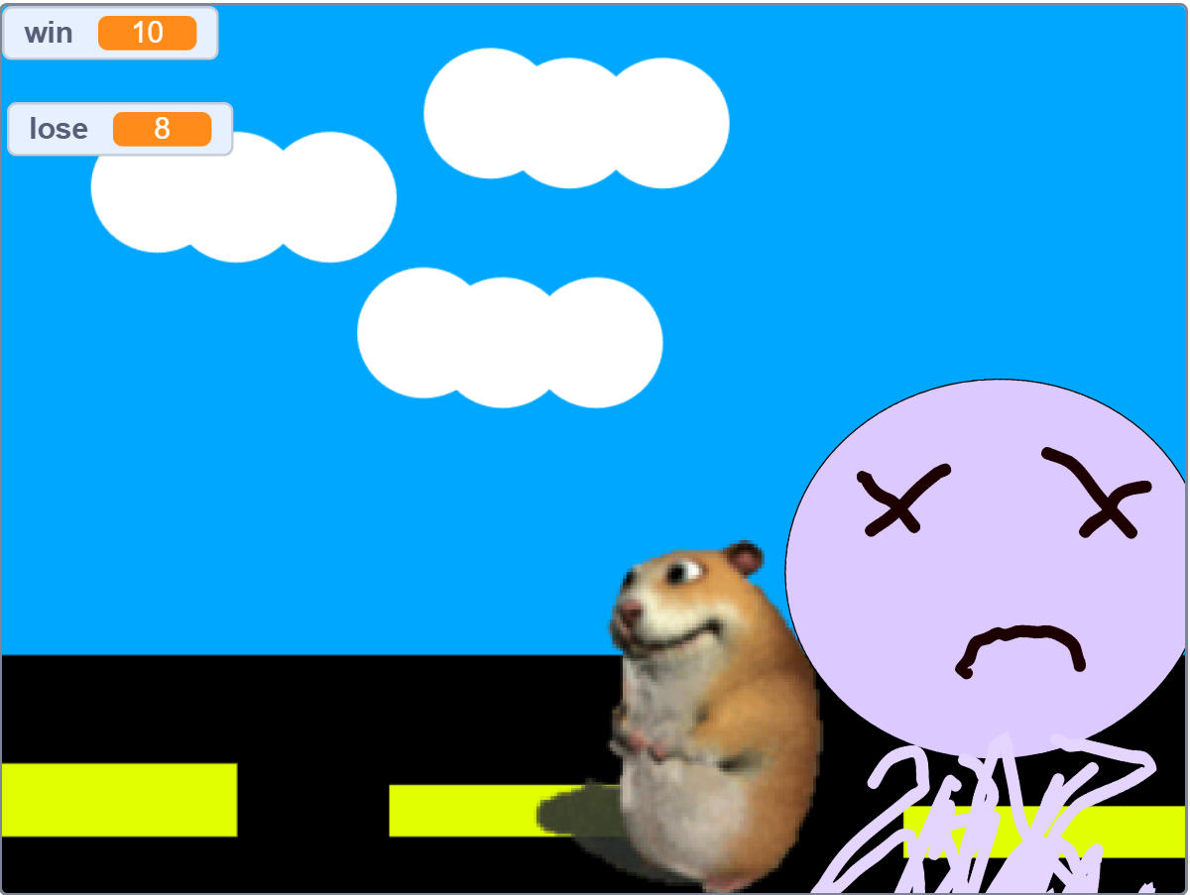 | This is my first ever scratch game, made when I was 8  Concept: Jump over obstacles  Goal: Win 100
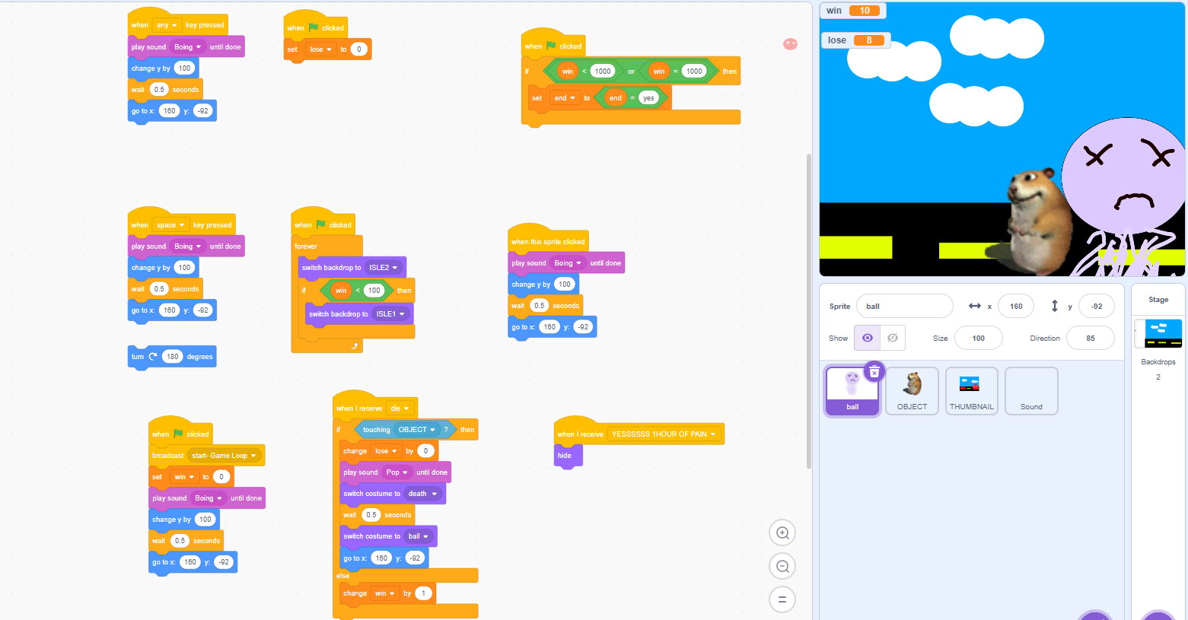 | Design:  - Player  -Background  -Objects to jump over  - Win/lose when objects collide
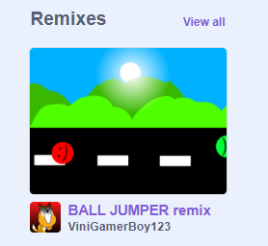 | Learning: Learnt the basic categories Motion, looks, sound, variables, operators, events ,sensing  Community:  -My game was reimagined by another person of the scratch community, (I thought this was cool)

Scratch Project 2
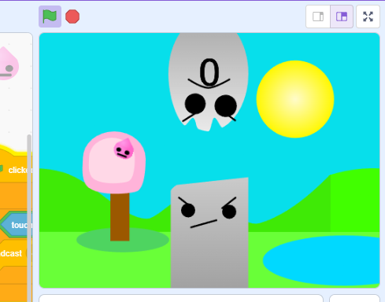  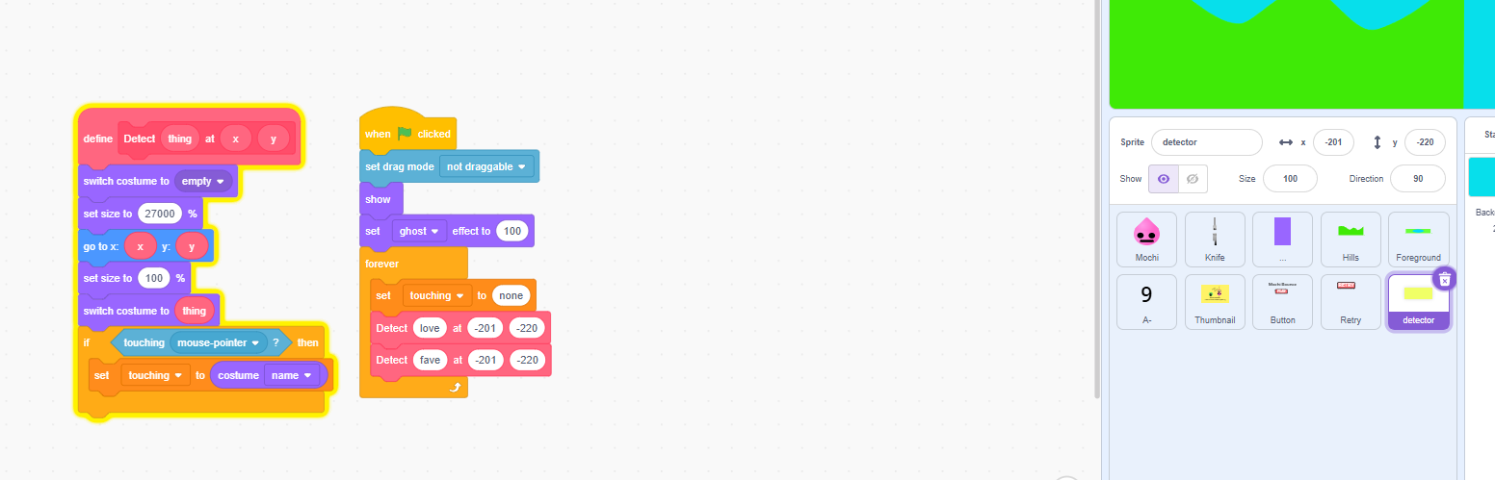 | This is the next big scratch project,  Age: 10  Concept: Flappy bird  Goal : To jump over 100 obstacles.
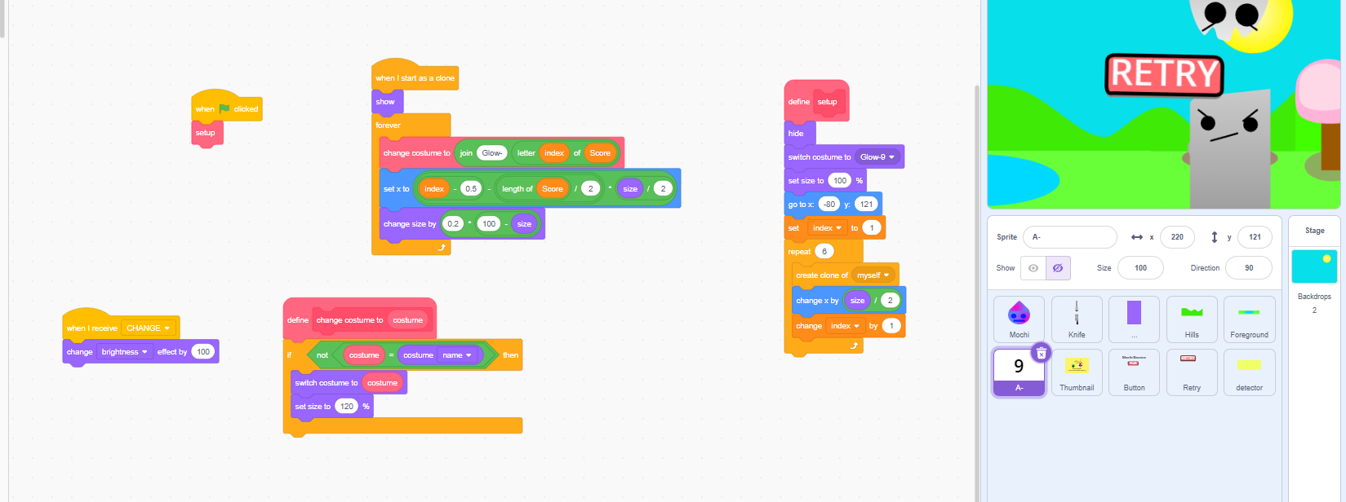  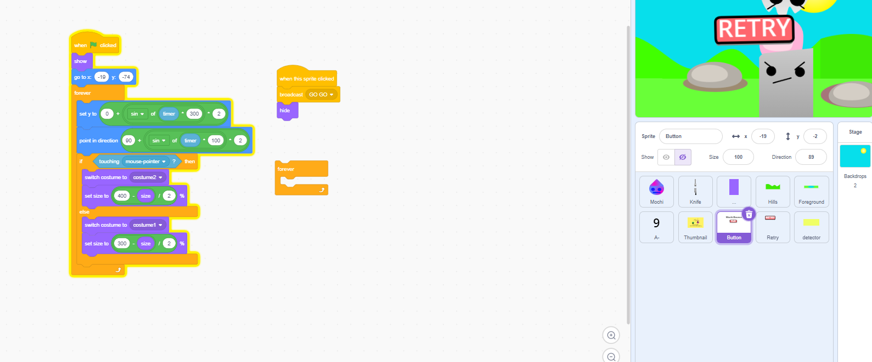 | Design:  - Player  - Pipe (Or in this case, fork)  -A collider for the pipe  -Start UI  -Retry UI  -Scrolling background  -Counter (amount of objects that have been passed)
Learnt:
-How to use broadcasts for game-loops (handy for retry UI)
-Implement UI into the game, Start, Retry button
-How to use manipulate clones (to create a scrolling bg)
-How to use functions

Scratch Project 3
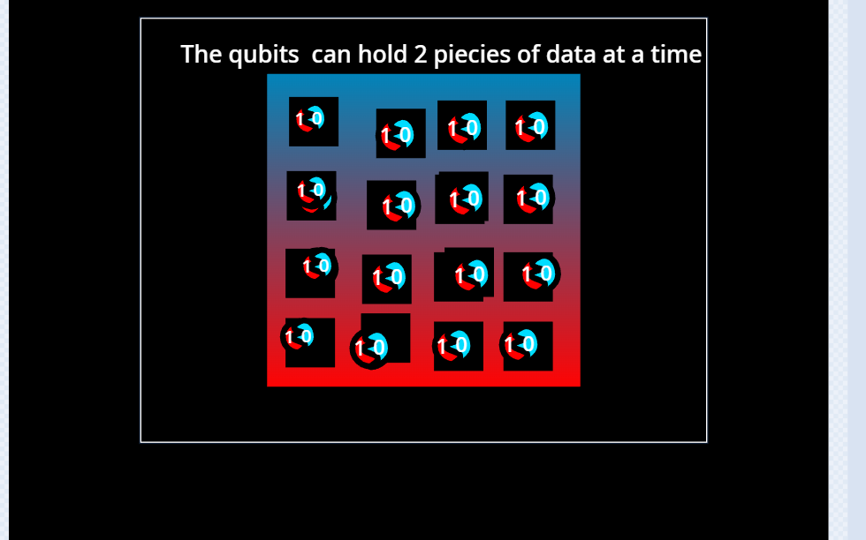 | This is an animation explaining the basics of quantum computing  Age: 12  Concept: Animation  Goal: to teach younger audiences about quantum computing. It is displayed in a cartoon like way
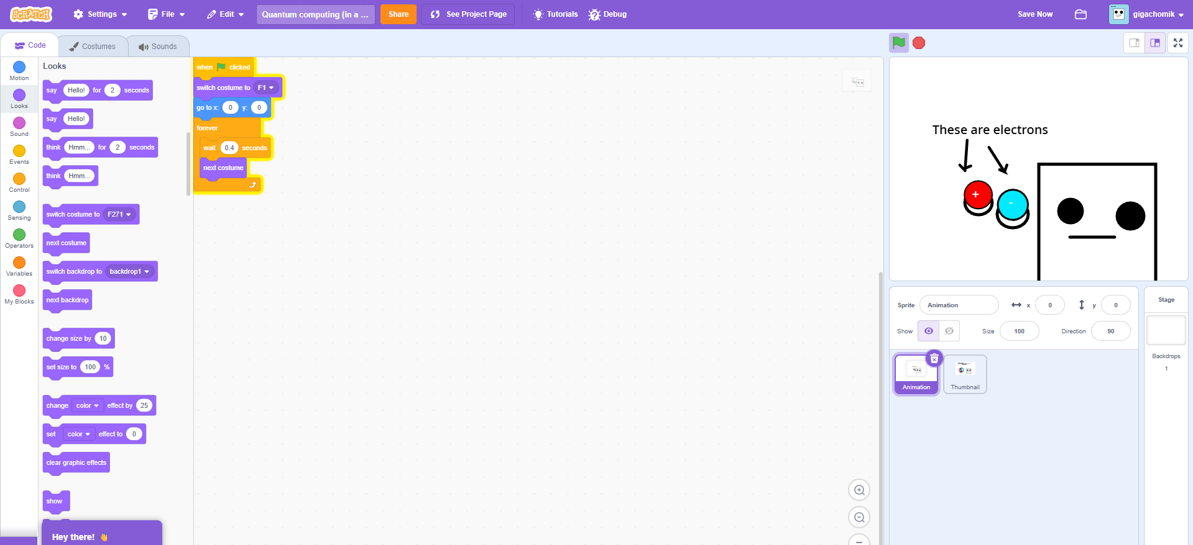 | Design:  -Thumbnail  -Animation (over 200 frames)
Learnings:
-Learnt the basics of quantum computing:
-Qubits
-Entanglement
-Superposition

